Full Name: Punyaja Mishra  
Student Number: 0660001

TOTAL POINTS: /30

Trent University MATH 2600 - Discrete Structures   
Instructor: Aras Erzurumluo˘glu

**TAKE-HOME FINAL EXAM (due 11:00 am on April 15th)**

**READ ME:** You may use any course material and the internet for reference, but you are required to solve the problems independently and follow the principles of academic integrity as stated within the university policies.

Show all your work. Explain your solutions when appropriate.

1. **(0 points): Prove something.**

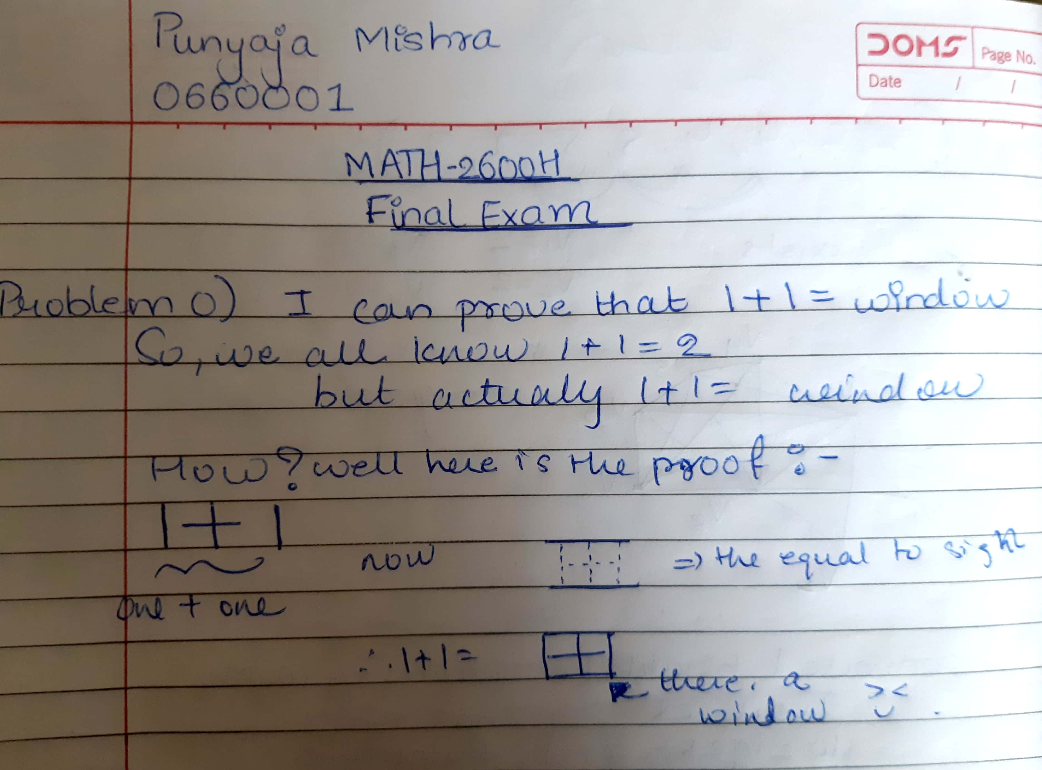

1. **(3 points): On the Island of Knights and Knaves we have two people A and B.**

**A says: B is a knight. B says: I am a knight or we are both knaves.**

**Is A a knight? Is B a knight? Show all your work. (The problem may have a single solution, multiple solutions, or no solution at all.)**

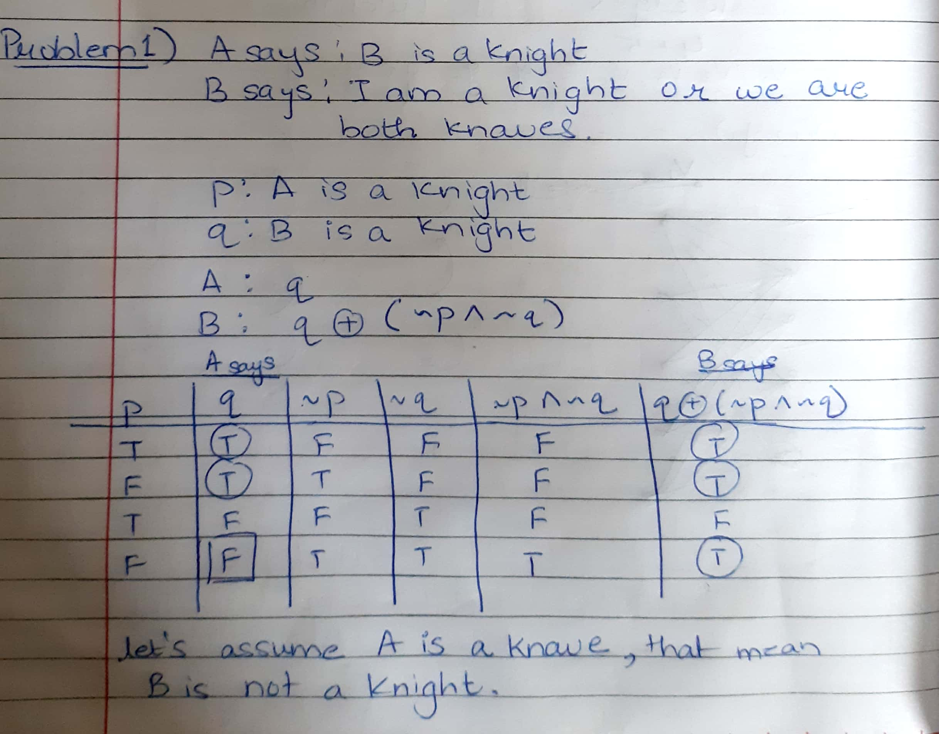

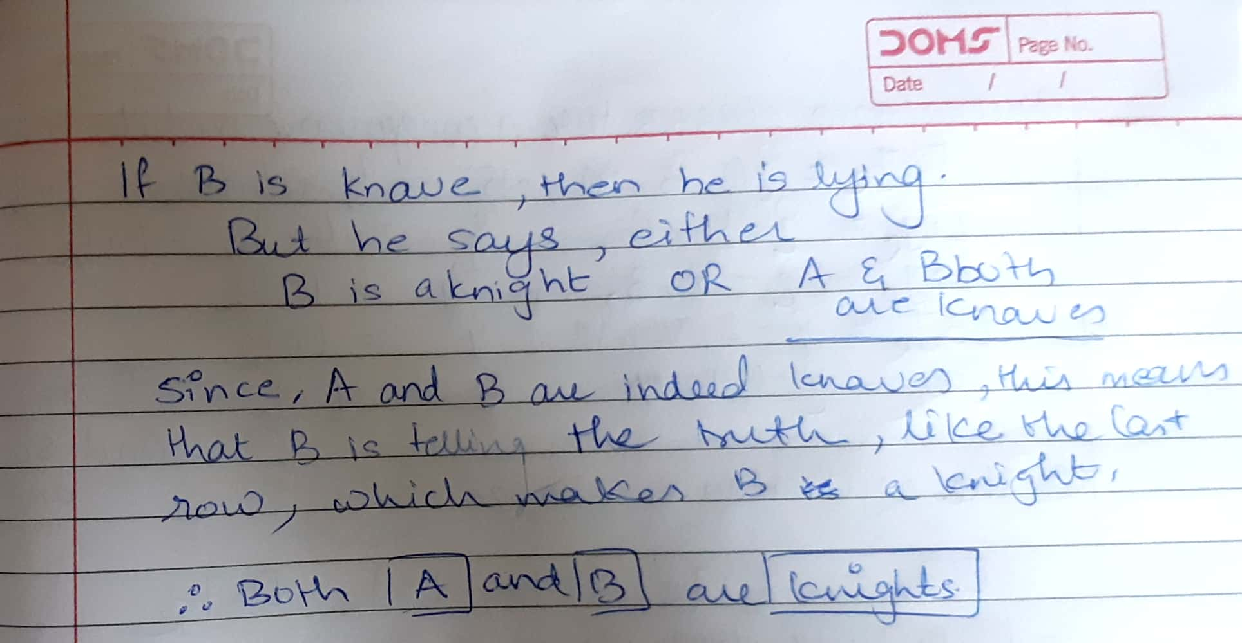

1. **(2 points): Consider the following relation on the set A = {1,2,3,4}: R = {(1,1),(2,2),(2,3),(3,2),(3,3),(3,4),(4,1)} What properties does the relation R possess? Circle the correct responses.**

**R is reﬂexive. T F**

**R is symmetric. T F**

**R is antisymmetric. T F**

**R is transitive. T F**

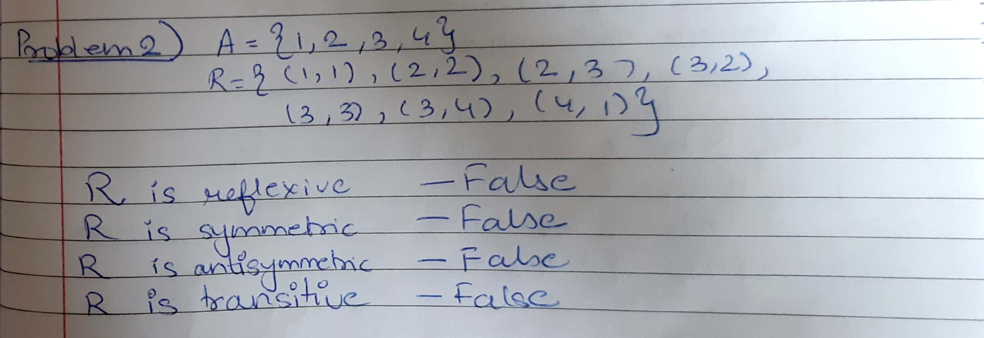

1. **(3 points): Let A = {−4,−3,0,1,6,9,10}, and deﬁne an equivalence relation R on A as follows: xRy ⇔ x ≡ y (mod 5). Find the partition of A into equivalence classes with respect to R. (You need to ﬁnd the equivalence classes of A, and then determine which elements in A belong to which equivalence classes.)**

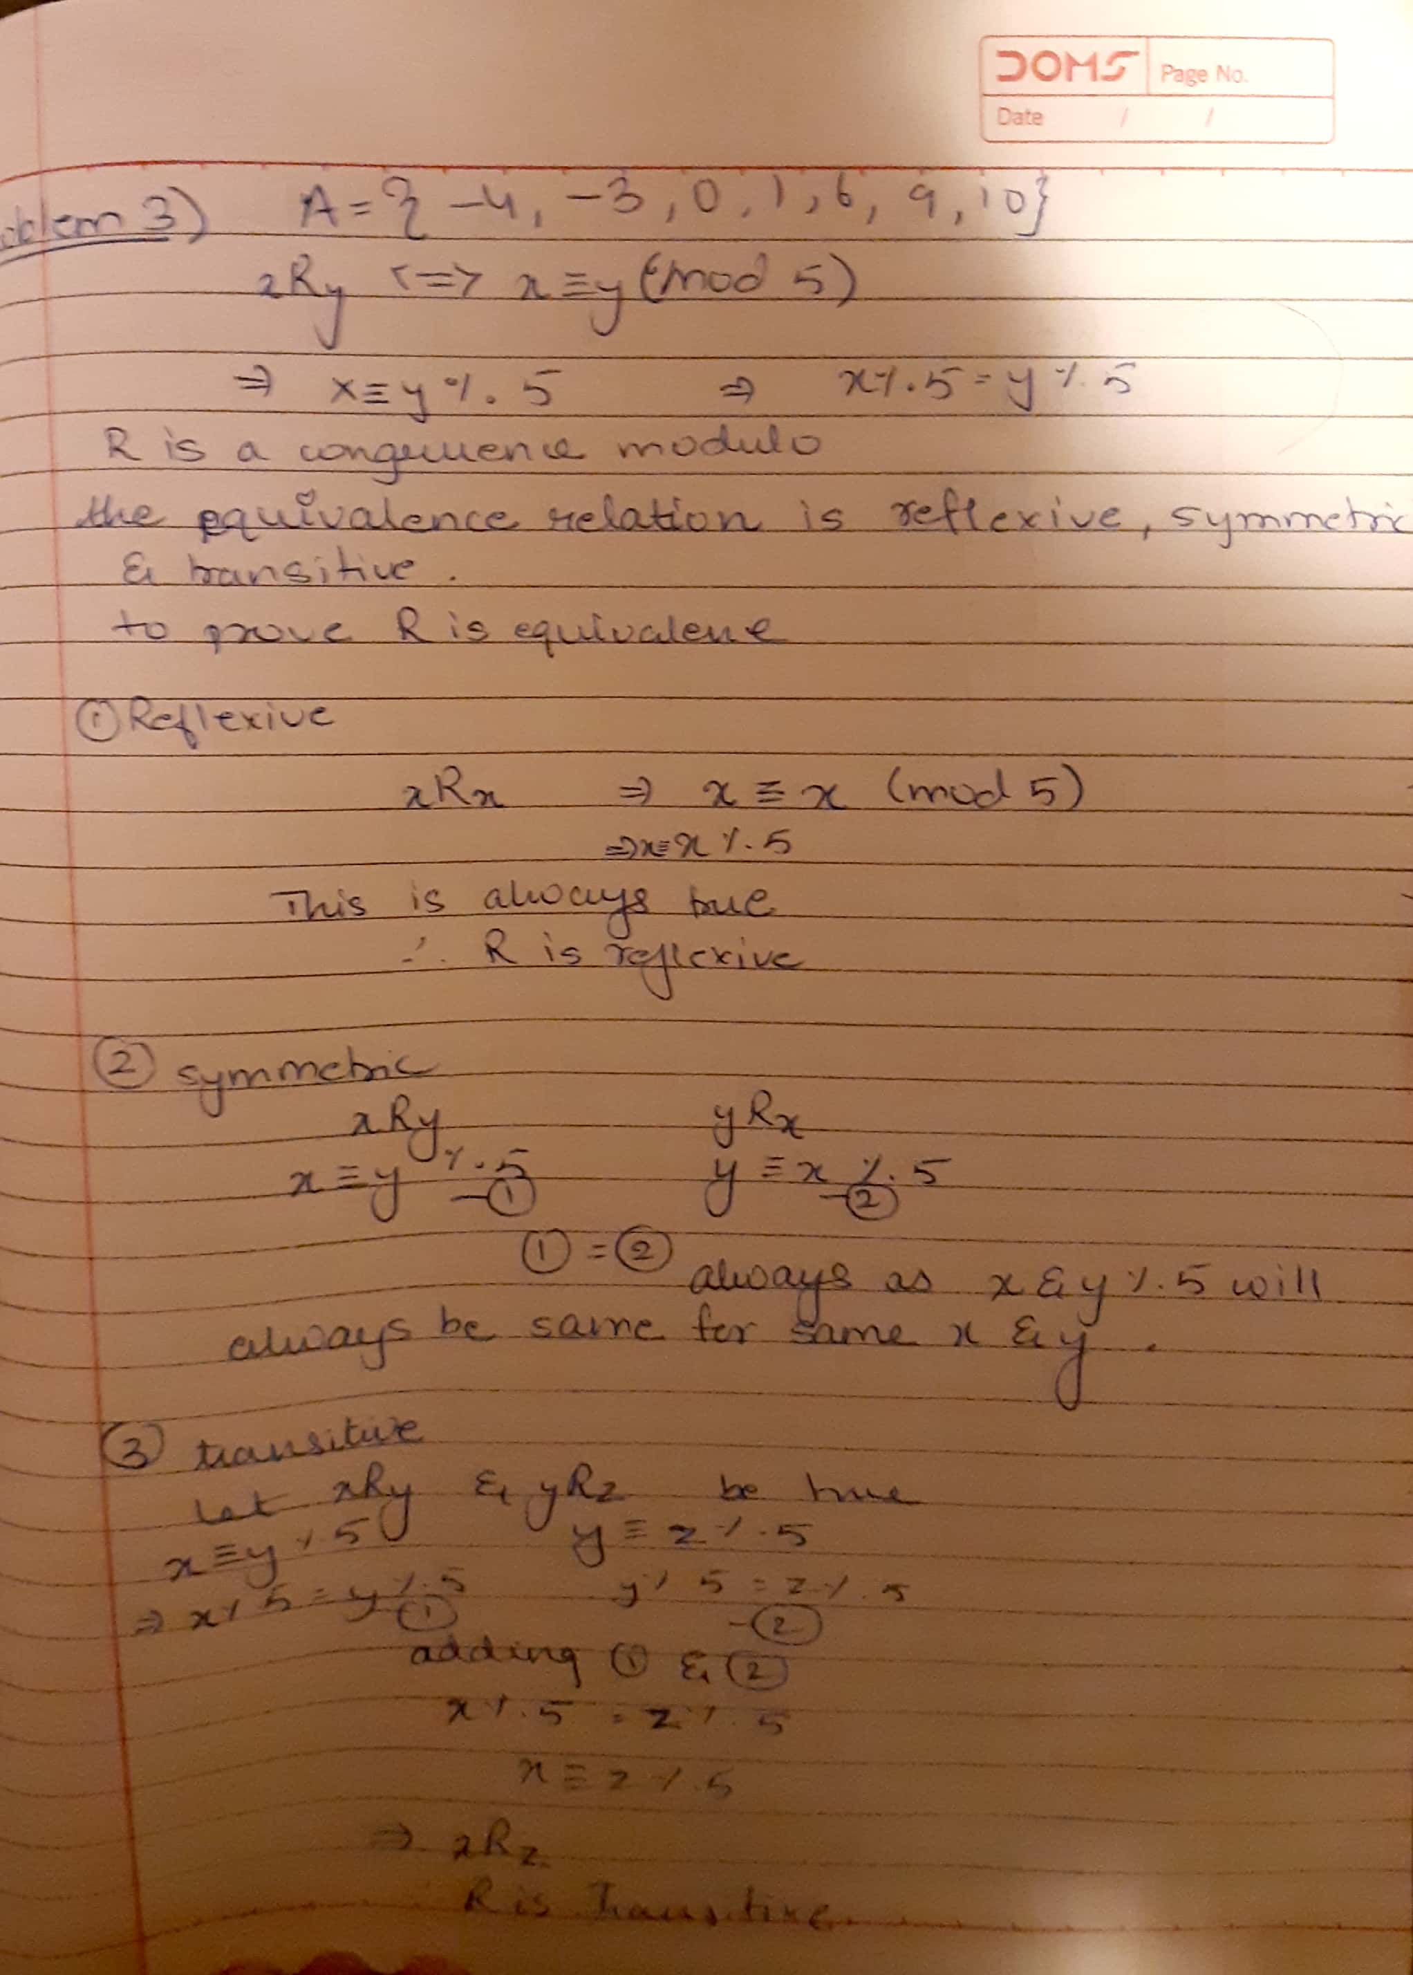

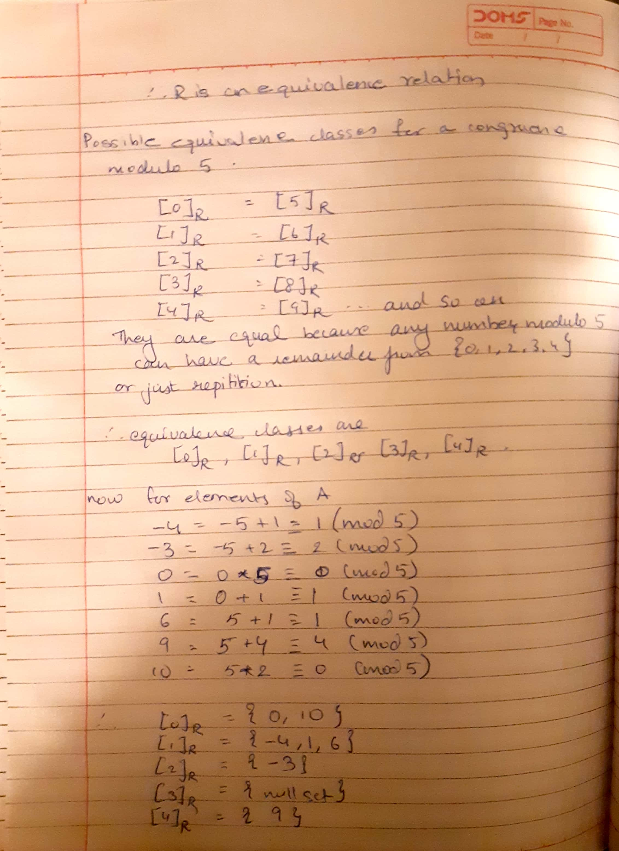

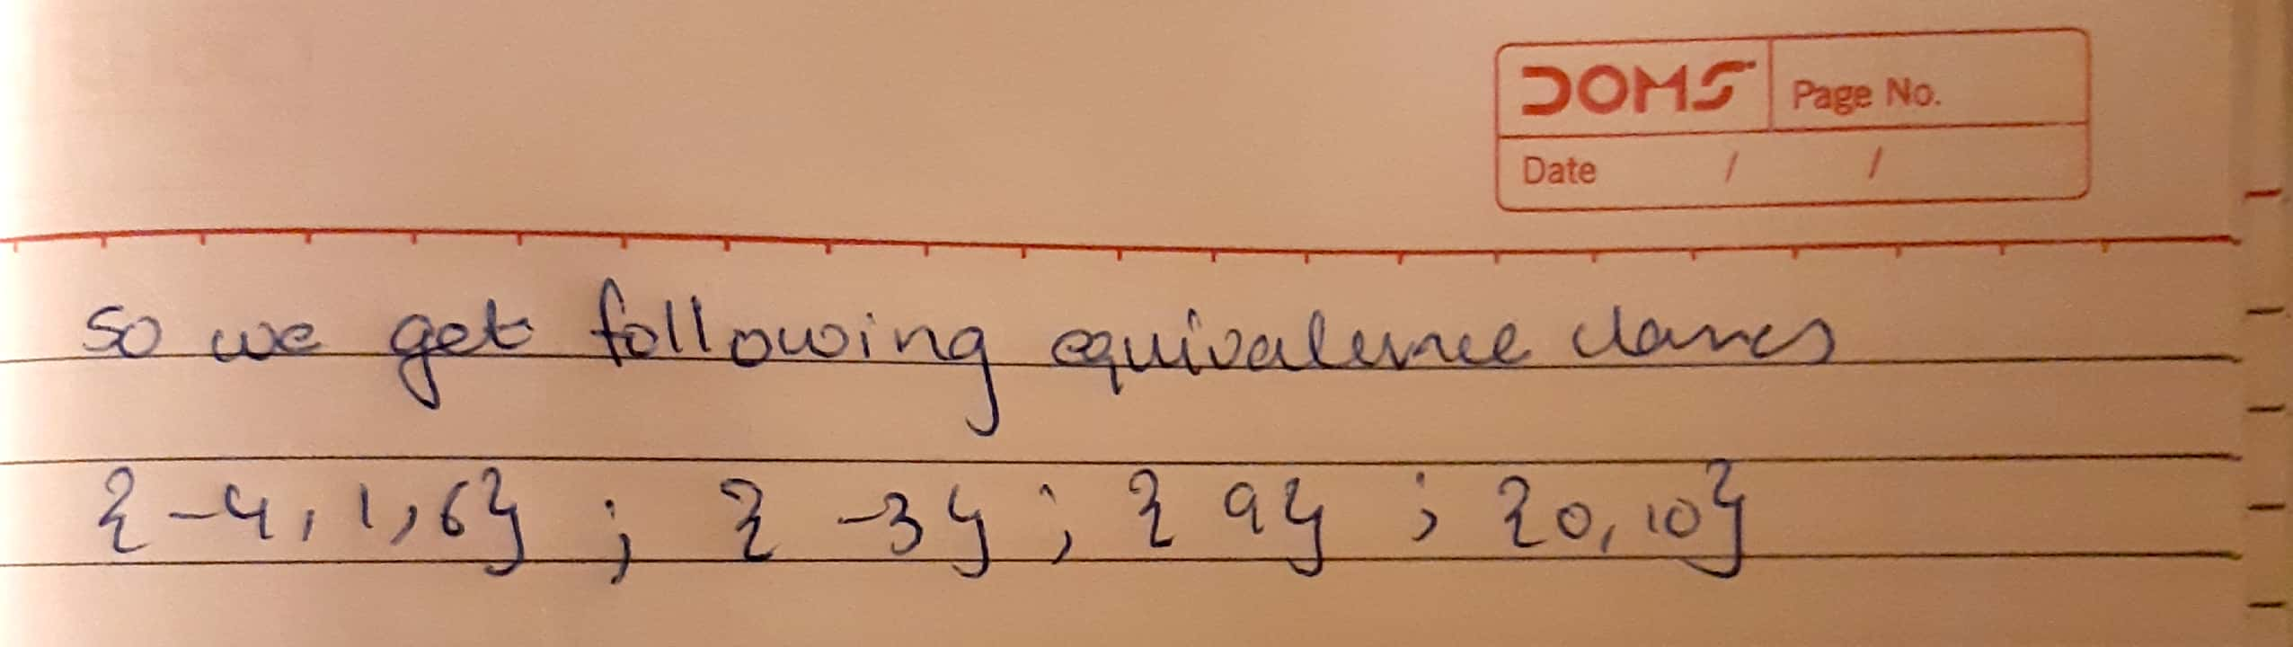

**4) (4 points): Let f : R→R×Z be a function deﬁned by f(x) = (x−3,4).**

**Which of the following statements about f are true? If you claim the statement is true, prove it; otherwise, give a concrete counterexample.**

**f is injective. T F Justiﬁcation (proof or counterexample):  
f is surjective. T F Justiﬁcation (proof or counterexample):**

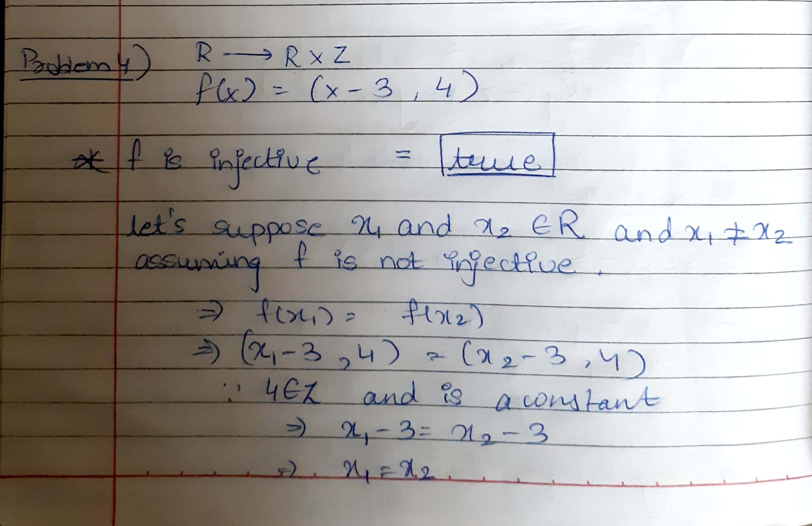

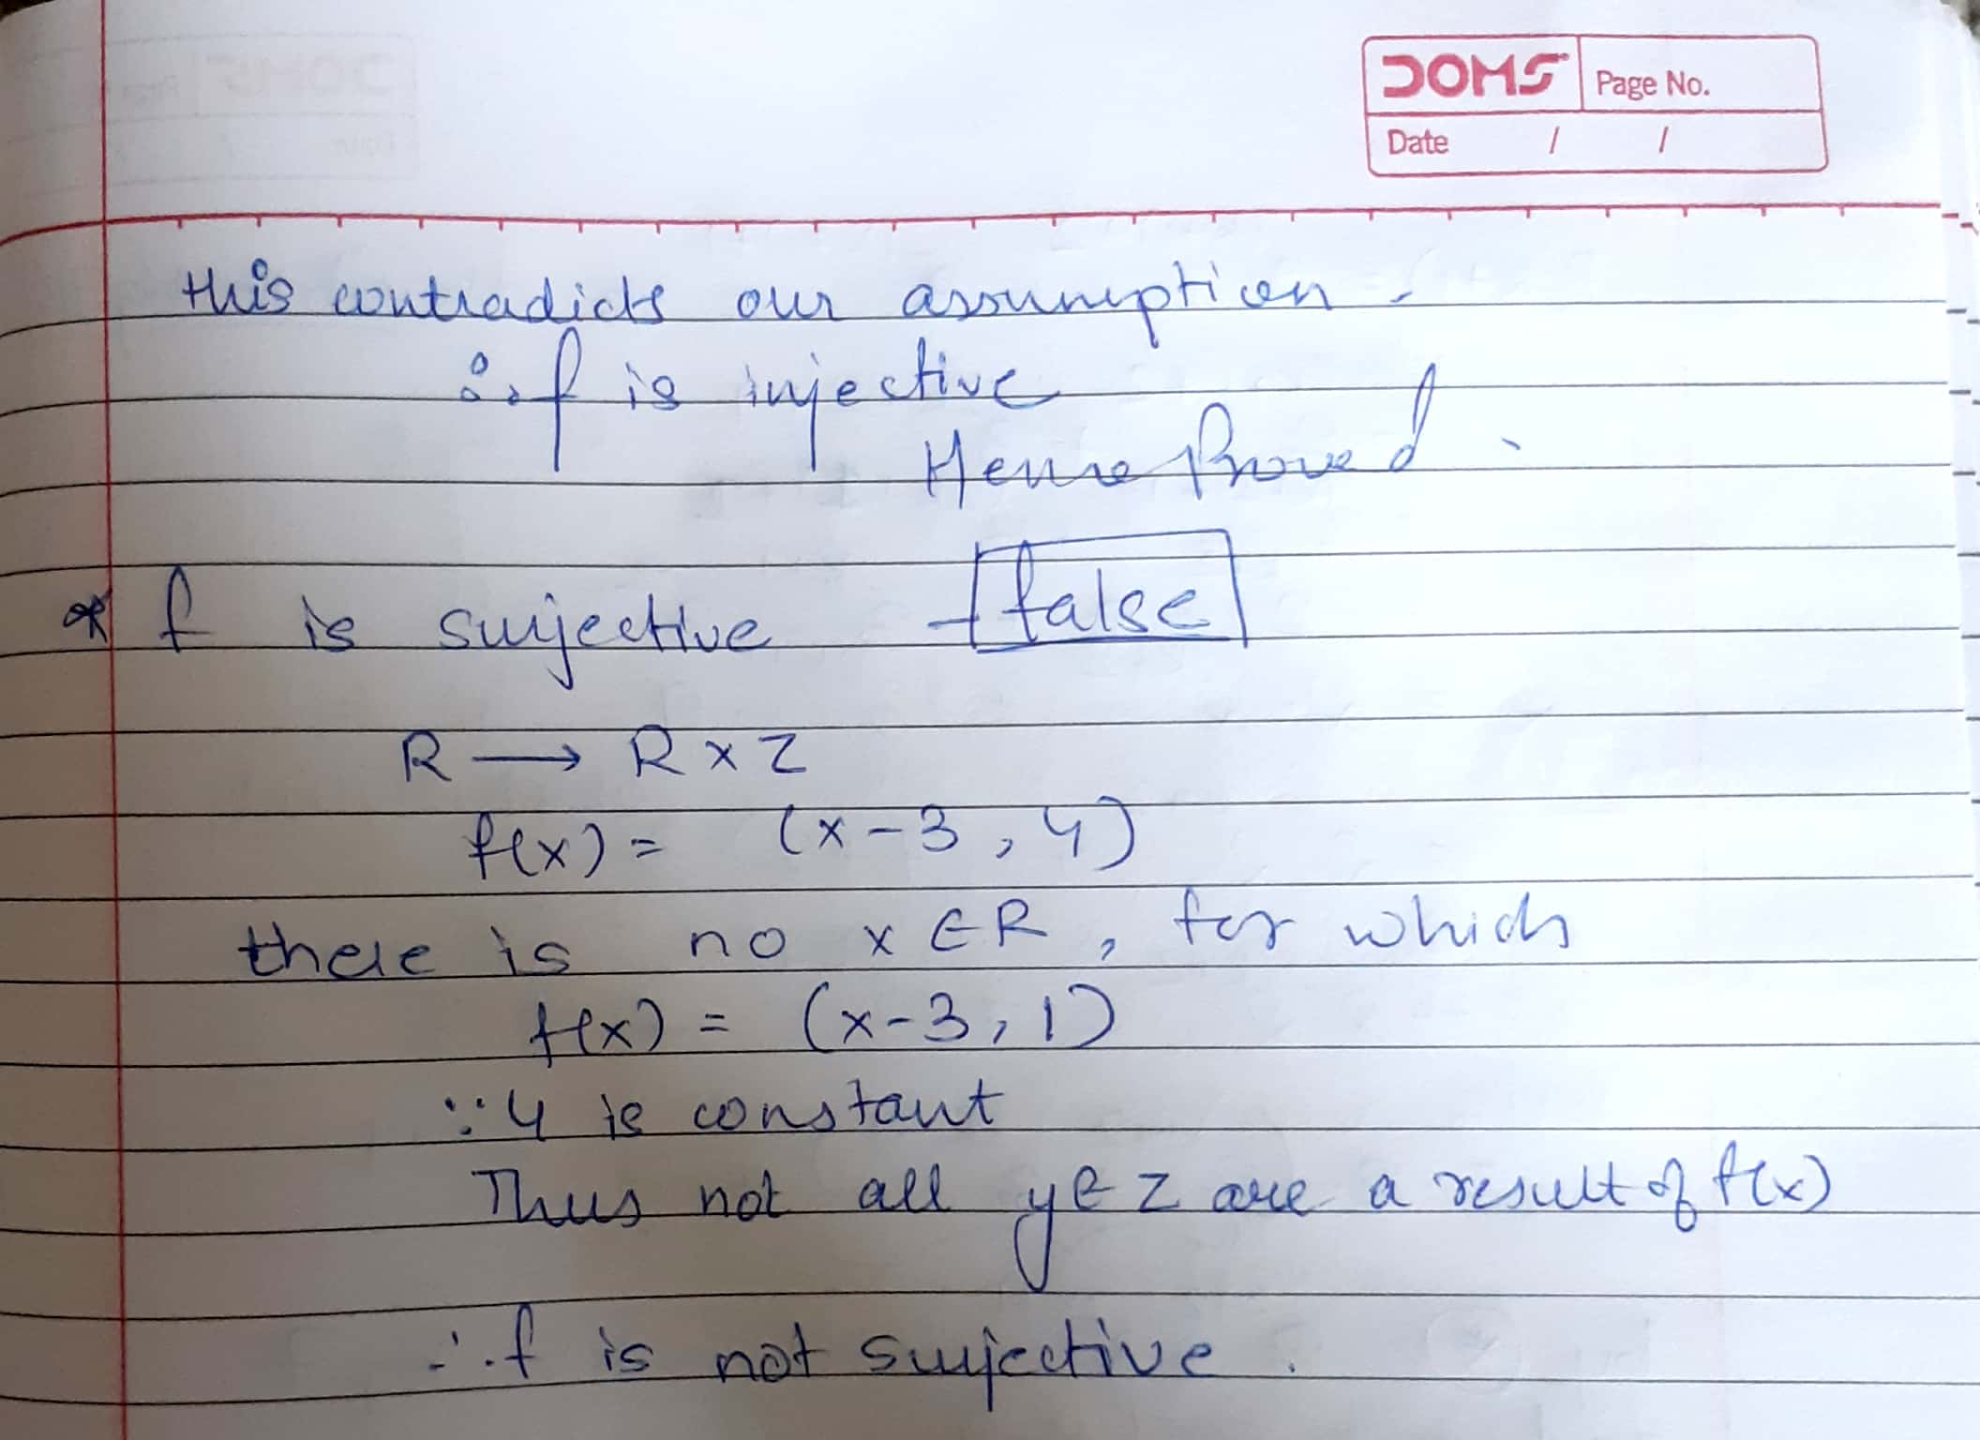

**5) (4 points): Use Mathematical Induction to prove that 2n+2+32n+1 is divisible by 7 for all integers n ≥ 0. Clearly state the proposition to be proved. Express the basis of induction, the induction hypothesis and the induction step. Indicate where the induction hypothesis is used in your proof.**

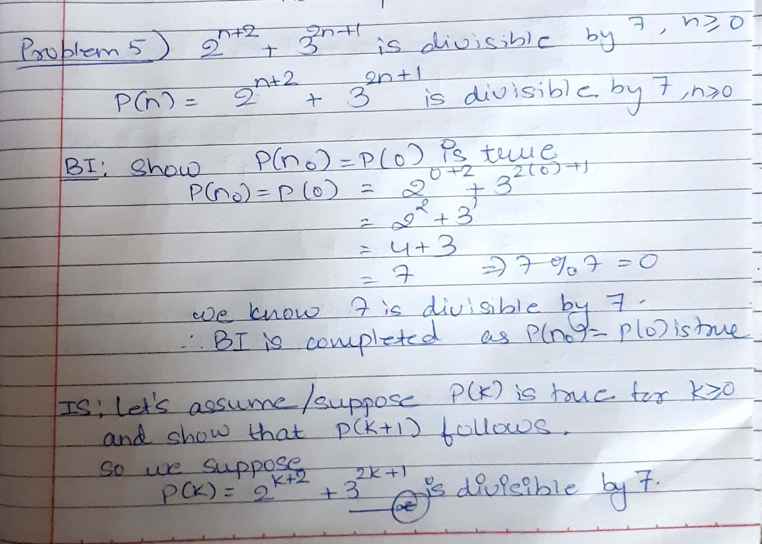

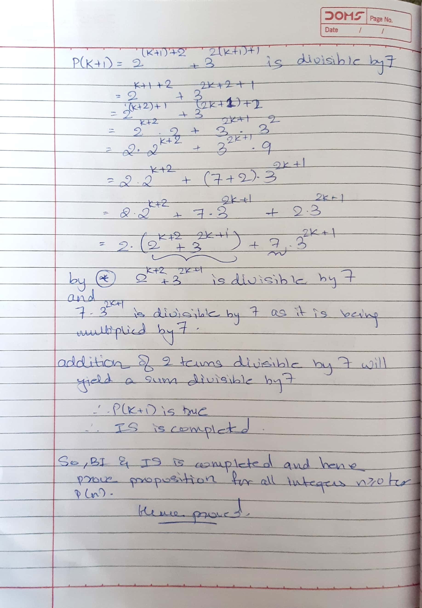

**6) (3 points): Solve the recurrence relation an = 8an−1 −16an−2 (n ≥ 2) with the initial conditions a0 = 3 and a1 = 14. Show all your work.**

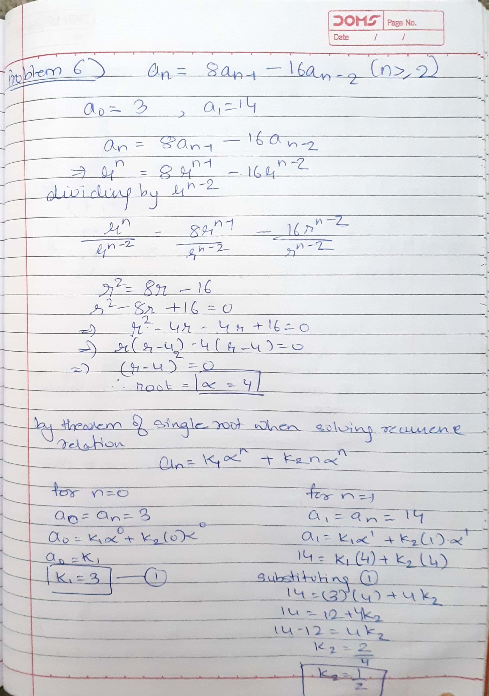

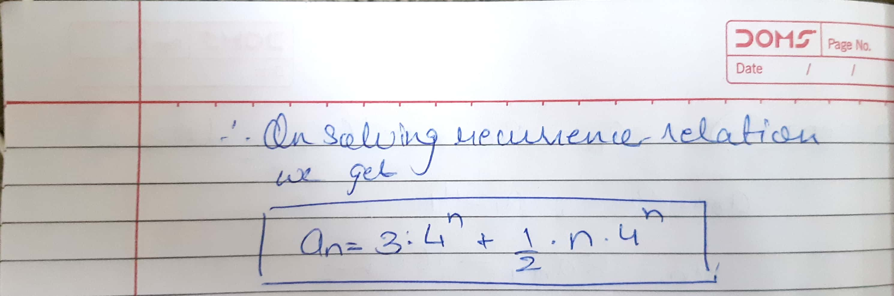

**7) (3 points): Does a simple graph with 8 vertices exist with degree sequence (2,2,4, 4,5,5,7,7)? If yes, then draw an example of such a graph; otherwise explain why it cannot exist.**

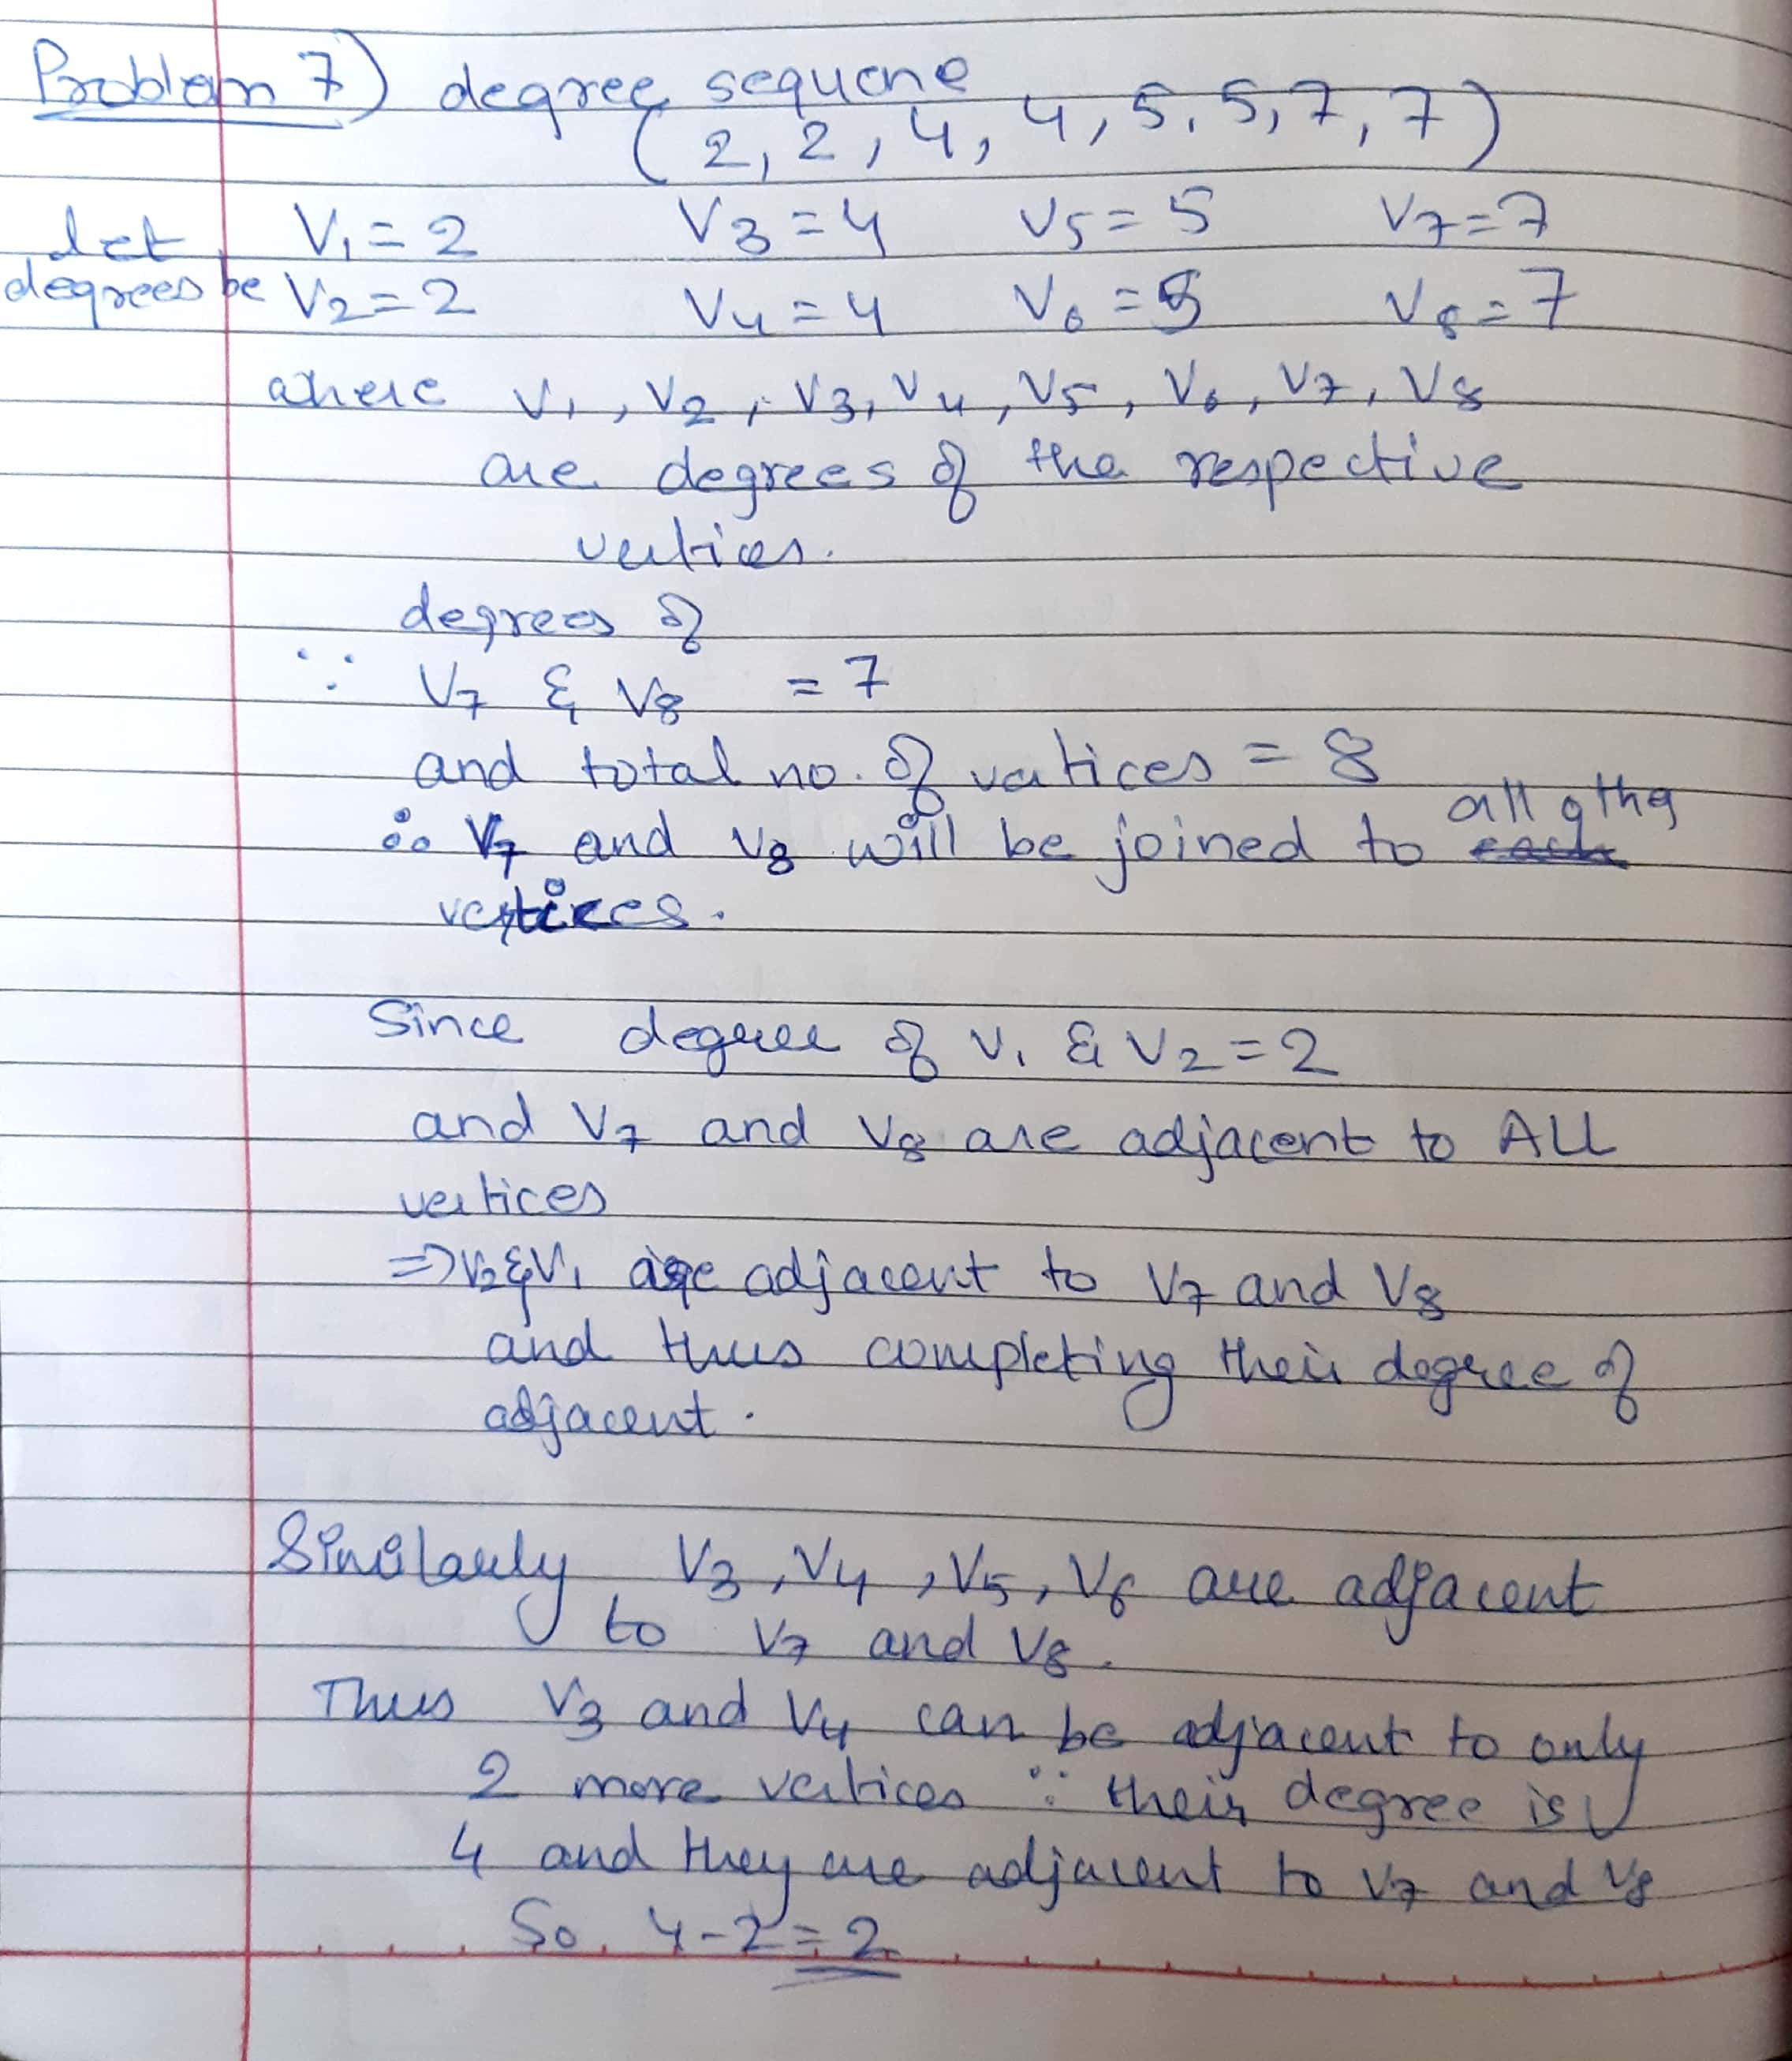

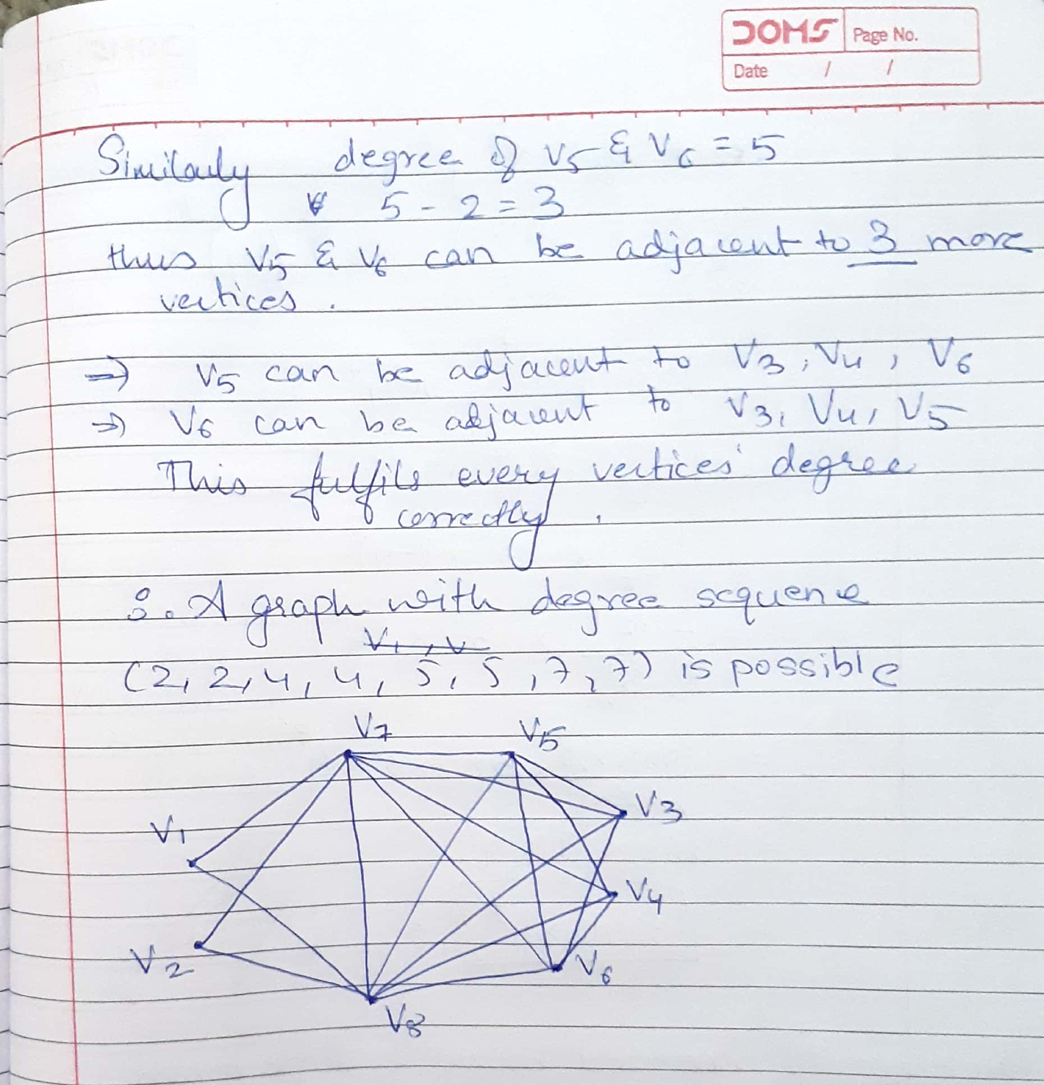

**8) (3 points): What is the coeﬃcient of x3y7 in the expansion of (3x−4y)10? Show all your work.**

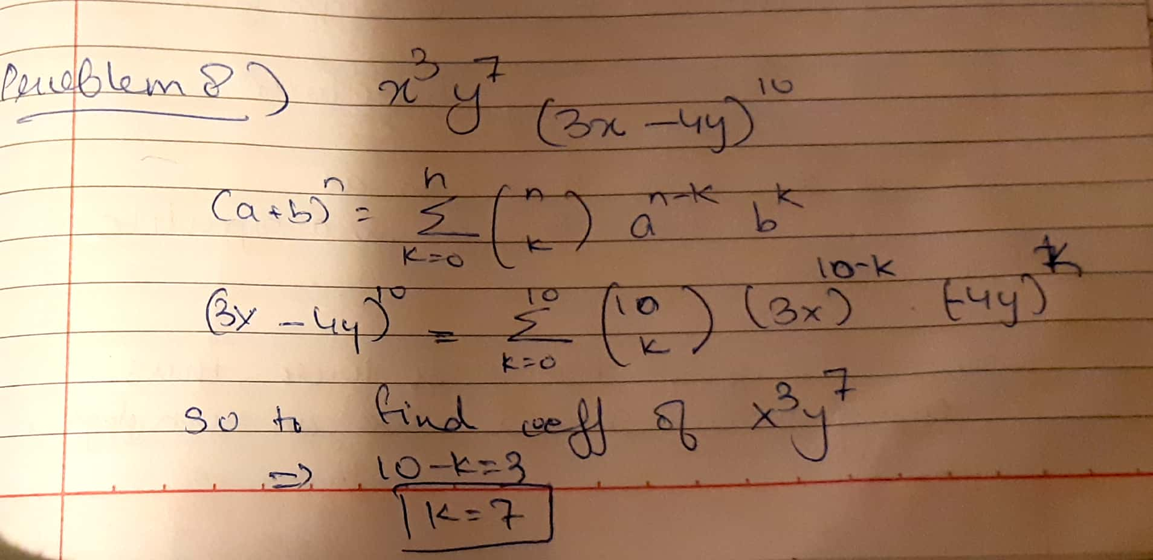

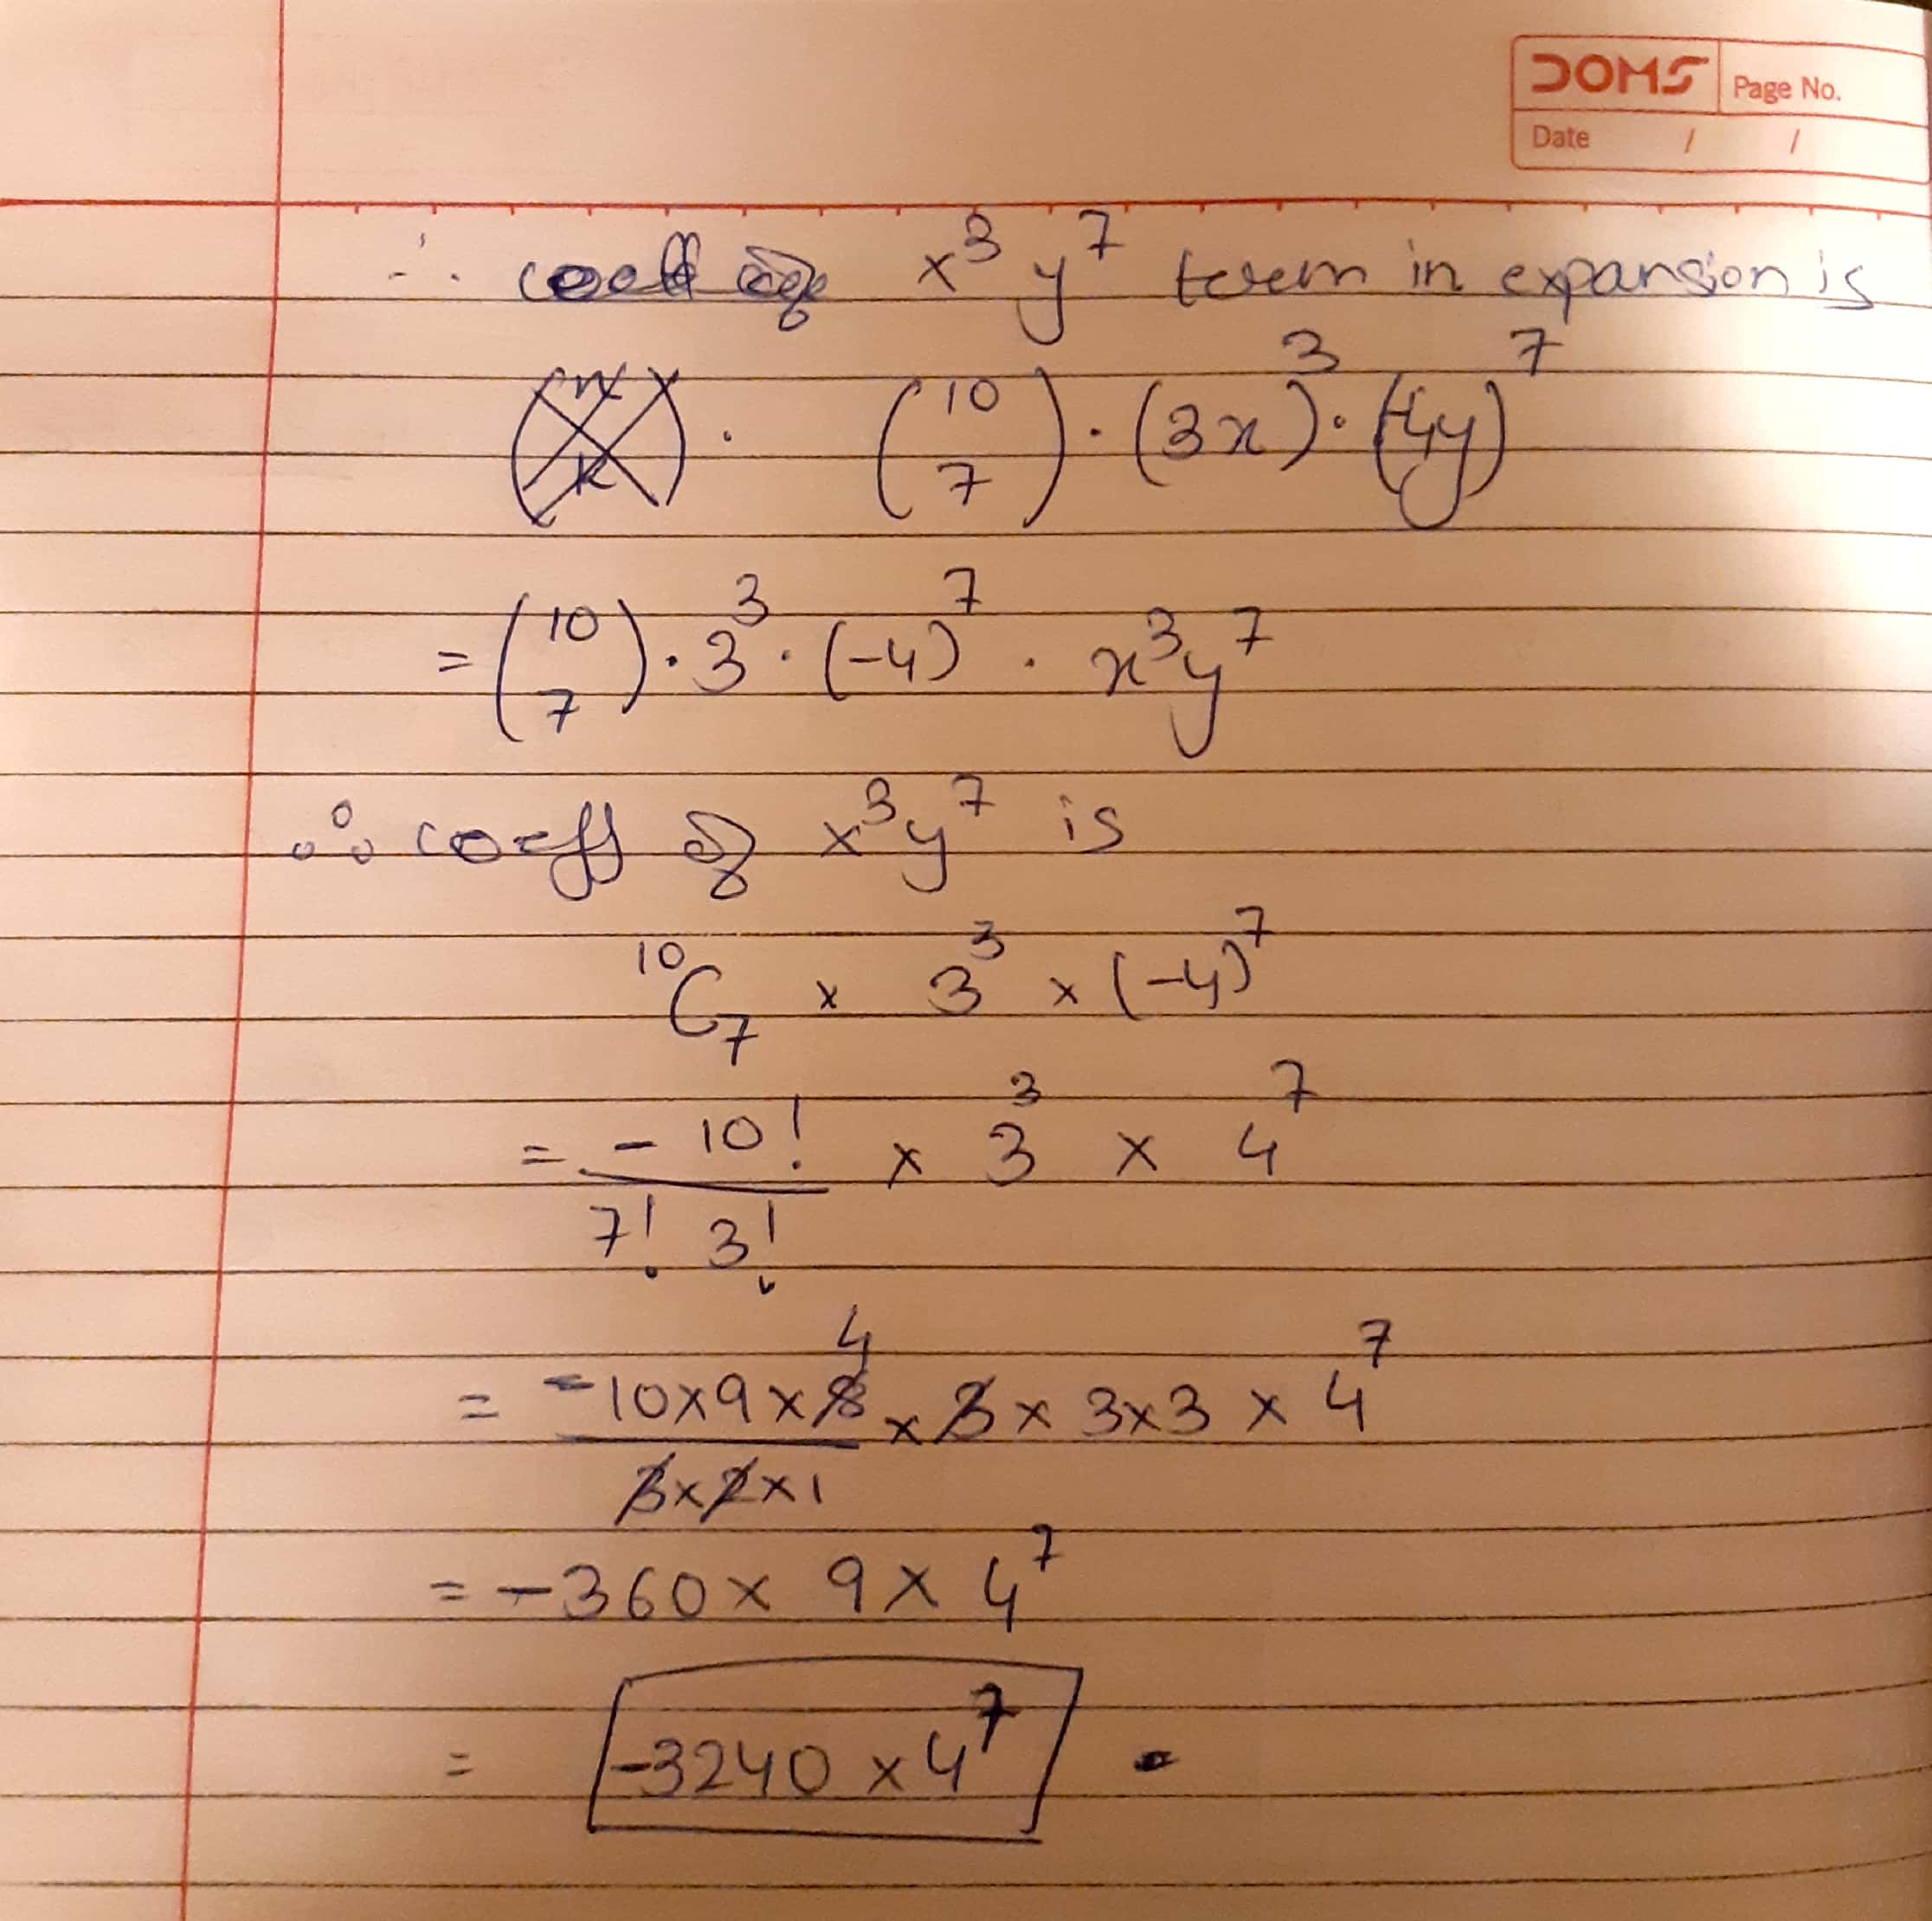

**9) (3 points): Draw an example of a connected bipartite simple graph with 9 vertices and 10 edges that has an Euler tour. Verify that your graph has these properties.**

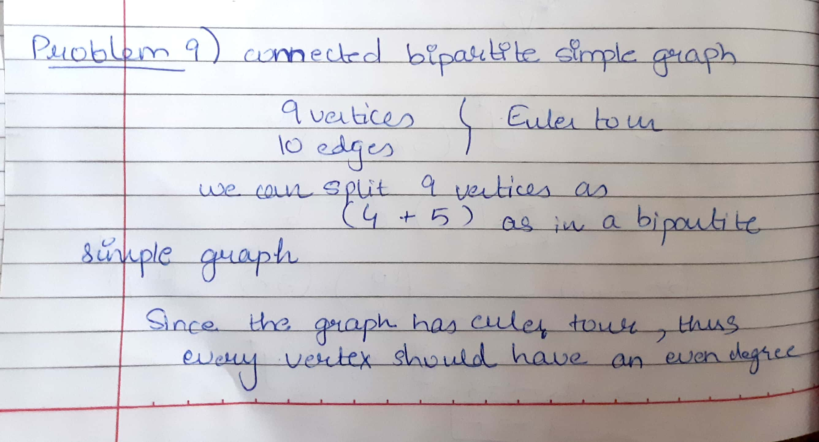

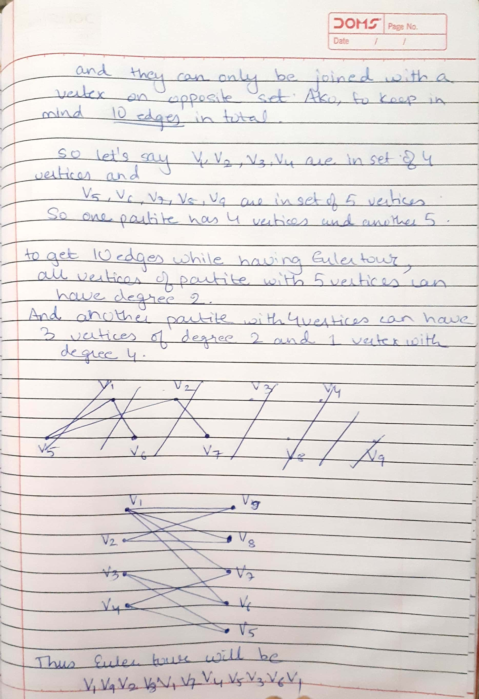

**10) (2 points): In how many ways can you arrange all letters in NOGOJIWANONG?**

